Performance Measurement

Zhao GuanChun

Date: 2014-09-28

Chapter 1: Introduction
There are two methods to print a list of N integers in the given order：the iterative method and the recursive method. The iterative method is very simple: just print the integers one by one through a for-loop. The recursive method is to equally divide the integer set into two parts by the integer in the middle position. Then recursively print the first part, followed by printing the integer in the middle, and finally the second part. What should we do is to implement the iterative version and the recursive version and then measure and compare the worst case performances of the above two functions,finally find the reason why one is better than the other.

Chapter 2: Algorithm Specification
IterativePrint
Begin: Run the function in main for K times.
Function:1.Get the number N //the total quantity of number in the list
2. i = 0; //Print the integers through a for loop
3. printf("%d\n", Num[i]);
4.IF i<N i=i+1;
End

RecursivePrint
Begin:Run the function in main for K times.
Function: 1.Get the HeadoftheRow and TailoftheRow
2.IF TailoftheRow!=HeadoftheRow
IF ((TailoftheRow-HeadoftheRow)%2)
printNum(HeadoftheRow,(TailoftheRow+HeadoftheRow)/2); //recursively print the first part of the list
printNum((TailoftheRow+HeadoftheRow)/2+1,TailoftheRow); //recursively print the second part of the list
3. IF TailoftheRow!=HeadoftheRow
IF ((TailoftheRow-HeadoftheRow)%2==1)
{
printNum(HeadoftheRow,(TailoftheRow+HeadoftheRow)/2-1); //recursively print the first part of the list
printf("%d\n",Num[(TailoftheRow+HeadoftheRow)/2]); //print the number in the middle
printNum((TailoftheRow+HeadoftheRow)/2+1,TailoftheRow); //recursively print the second part of the list
}
}
4.IF HeadoftheRow==TailoftheRow //it's the end of the recursion
{
printf("%d\n", Num[HeadoftheRow]); //print the number
}
End

Chapter 3: Testing Results
Test cases include eight files, 100.in, 500.in, 1000.in, 2000.in, 4000.in, 6000.in, 8000.in and 10000.in. Each of them contains some numbers as their filename shows.
In order to satisfy the requirement of accuracy and calculation convenience, we chose 10 as our repetition factor (K).
The testing result is presented below as a table.
 | N | 100 | 500 | 1000 | 2000 | 4000 | 6000 | 8000 | 10000
Iterative version | Iterations (K) | 10 | 10 | 10 | 10 | 10 | 10 | 10 | 10
Iterative version | Ticks | 140 | 393 | 686 | 1232 | 2449 | 3978 | 5319 | 6021
Iterative version | Total Time (sec) | 0.140 | 0.393 | 0.686 | 1.232 | 2.449 | 3.978 | 5.319 | 6.021
Iterative version | Duration (sec) | 0.0140 | 0.0393 | 0.0686 | 0.1232 | 0.2449 | 0.3978 | 0.5319 | 0.6021
Recursive version | Iterations (K) | 10 | 10 | 10 | 10 | 10 | 10 | 10 | 10
Recursive version | Ticks | 143 | 367 | 701 | 1279 | 2652 | 3650 | 4929 | 6131
Recursive version | Total Time (sec) | 0.143 | 0.367 | 0.701 | 1.279 | 2.652 | 3.650 | 4.929 | 6.131
Recursive version | Duration (sec) | 0.0143 | 0.0367 | 0.0701 | 0.1279 | 0.2652 | 0.3650 | 0.4929 | 0.6131

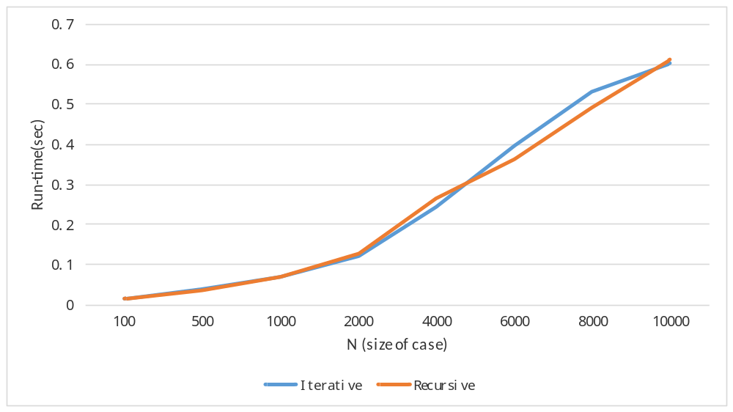Corresponding line chart based on the result is presented below.
Ticks: computer’s time ,1Ticks=0.001s.
Total Time:time of the function running for K times.
Duration: time of the function running one time.

Chapter 4: Analysis and Comments
Based on pseudo-code given in Chapter 2, our analysis follows as below. It will be divided into two parts.
The algorithm IterativePrint occupies four lines. Suppose that comparison, calculation, printing all take a same unit of time. It need to do printing and addition for N times, comparison for N+1 times and assignment for only 1 time as initial part. So the time complexity is O(N) . It only needs some invariant space in for loop. Hence, the space complexity is O(1).
The algorithm RecursivePrint seems to be more complicated. Also, we suppose that function calling takes the same time as printing. First, no doubt it does printing for exactly N times. Next, as for the number of calling, approximately it calls for logN time because it always break the problem into two parts. And each calling involves several calculation when passing the parameter and comparison in the if statement. All in all, the time complexity is O(N) either. While every time it call another function, it needs additional space. Therefore, the space complexity is O(logN).
According to the line chart, the runtime of two algorithms increase in asymptotically linear manner, which accords with our analysis. And due to slight variation in the computing environment, it’s almost impossible to determine performance difference between them exactly.

Appendix: Source Code (in C)
At least 30% of the lines must be commented. Otherwise the code will NOT be evaluated.

Declaration
We hereby declare that all the work done in this project titled "XXX" is of our independent effort as a group.

Duty Assignments:
Programmer: 陆宽
Tester: 田黄石
Report Writer: 赵冠淳

Please keep in mind that these are the “minimum” requirements. Other requirements will be specified according to each project assignment.

Group of Three – Duty Assignments

- Programmer: Write and maintain the source code. (50 pts.)
- Tester: Fill in the contents of Chapters 3 and 4. (30 pts.)
- Report Writer: Write up one complete project report in a uniform style. (20 pts.)

Hand-in

Each group is supposed to hand in a zipped file named as G##_P#.zip (or .rar), where ## is the two-digit group number which will be given to you after your group is confirmed, and the last # is the project number (for example, G08_P2.zip or G08_P2.rar). The zipped file must contain the following:

G##_P#.zip
documents
code
If there are two or more files, then a readme.txt must be included to tell your reader the proper order of browsing.
Source code files (*.c, *.h)
Executable file (in case your code cannot be compiled by Judge)
Readme.txt (instructions on how to build the executable file and how to run it.)

Note: Your report document must be saved as a PDF file. The names of your report document and your source code file must be in the format Teacher_YourGroupID_ProjectNumber.*. For example, “hqm_G03_P2.pdf” is considered to be the report for Project 2 by Group 03, and the instructor is represented by “hqm”.
Project reports are supposed to be submitted through the online system at http://www.cs.zju.edu.cn/ds/ with your group account which will be given to you after your group is confirmed.

Late Penalty

Each assignment is due at 10:00pm on a specified date. The door for submission will be closed automatically afterwards. Late assignments will have to be sent to your teaching assistant through email (hz_stb@163.com). The assignments received between 10:01pm – 11:59pm on the day they are due will be penalized 5% of the points on that lab. After the due date, the penalty will be 10% for each day they are late.

